**Wayfair**

**‘SHIPS IN TIME’ CAMPAIGN ANALYSIS REPORT**

Submitted by:

Roli Arah

Prateek Barve

**Introduction**

The objective of this report is to analyze the success of Wayfair’s ‘Ships in Time’ campaign, which guaranteed delivery of orders to a test group by Christmas referred to as group B herein. There was also a control group, group A, which was not shown this guarantee. This report makes comparisons between both groups and uses certain metrics to measure the success or lack thereof of this campaign.

**Section A: Exploratory Data Analysis**

The dataset consists of a number of variables listed below with the most critical one being the guarantee shown variable. This variable is a factor that splits the data into two groups, 0 representing the control group, group A, who weren’t shown the guarantee and 1 representing group B. There are a total of 123,542 observations out of which 40,087 (32.5%) were shown the guarantee while 83,455 were not. A baseline parameter percentage of 33% was created to represent the percentage of the observations shown the guarantee. This parameter can be used as a reference/baseline line to measure actual vs. expected performance.

|  |  |  |
| --- | --- | --- |
| **Dimensions/Categorical** | **Dimensions/Categorical** | **Measures/Numerical** |
| Customer_Session_Start_Date | Customer_Estimated_Delivery_Date | Purchased_Qty |
| Order_ID | Customer_Actual_Delivery_Date | Returned_Qty |
| Order_Product_ID | Visitor_Type_ID |  |
| Product_ID | Vistor_Type_Name |  |
| Canceled | Platform_ID |  |
| Guarantee_Shown | Platform_Name |  |
| **Dimensions/Categorical** | **Dimensions/Categorical** |  |
| Product_Category | Customer_ID |  |
| Total_Order_Value | ShipClassName |  |

The Total Order value variable contained a range of prices for each order and a calculated field was created out from this information to get the product price. The mid-price of each range was used as the product price. Our analysis utilized these product prices to create a revenue field by multiplying the product prices with purchased quantities.

"C:\Users\roe50\OneDrive\Documents\My Tableau Repository\Workbooks\Wayfair project.twbx"

**Business Question 1:**

What are the TOP product Categories by quantity purchased?

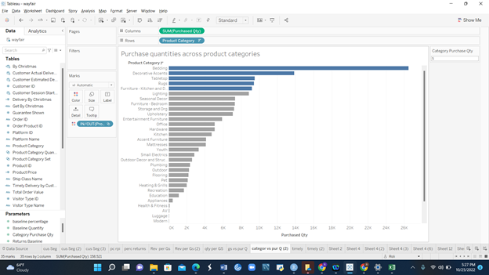

Figure 1

This horizontal bar chart compares the quantity of purchases for each product category.

The visualization through the creation of a set and parameter shows the product categories from highest to lowest based on purchase quantity. In the chart, the set is displayed in color and the parameter reveals the TOP N product categories based on the number typed in.

The chart answers the business question and shows the TOP five categories by Purchase quantity are Bedding, Decorative accents, Table Top, Rugs, and Furniture. These items are in the set while the other product categories are not included. The number of results can be adjusted according to what is required through the use of the parameter.

**Section B: Was the campaign successful?**

**Business Question 2:**

What was the average revenue per unit purchase for each group?

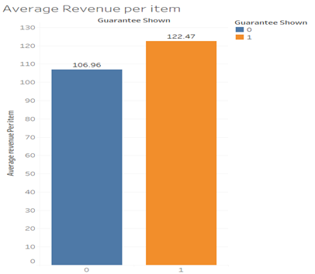

Figure 2

The bar chart visualization in Figure 2 compares the average revenue per item purchased in both the test and control groups. A calculated field was created for the average revenue per item (i.e. total revenue divided by total purchase quantity). The guarantee shown is color blue representing the control group and orange for the ‘Ships in Time’ group. The data shows that each item purchased from the group that saw the guarantee generated more revenue on average of $122.47 compared to $106.96 for the control group. This is a positive for the campaign provided Wayfair keeps the cost of the guaranteed shipping group below $15.50 per item sold, which is the difference in Revenue per item between the groups.

The chart shows that group B contributes more revenue for every purchase. Revenue is the strongest metric for determining Wayfair’s campaign success and the data indicates that the campaign has been successful from the perspective of generated revenue.

**Business Question 3:**

How did the campaign perform across the various customer segments (Visitor types) in terms of revenue generated per unit sale?

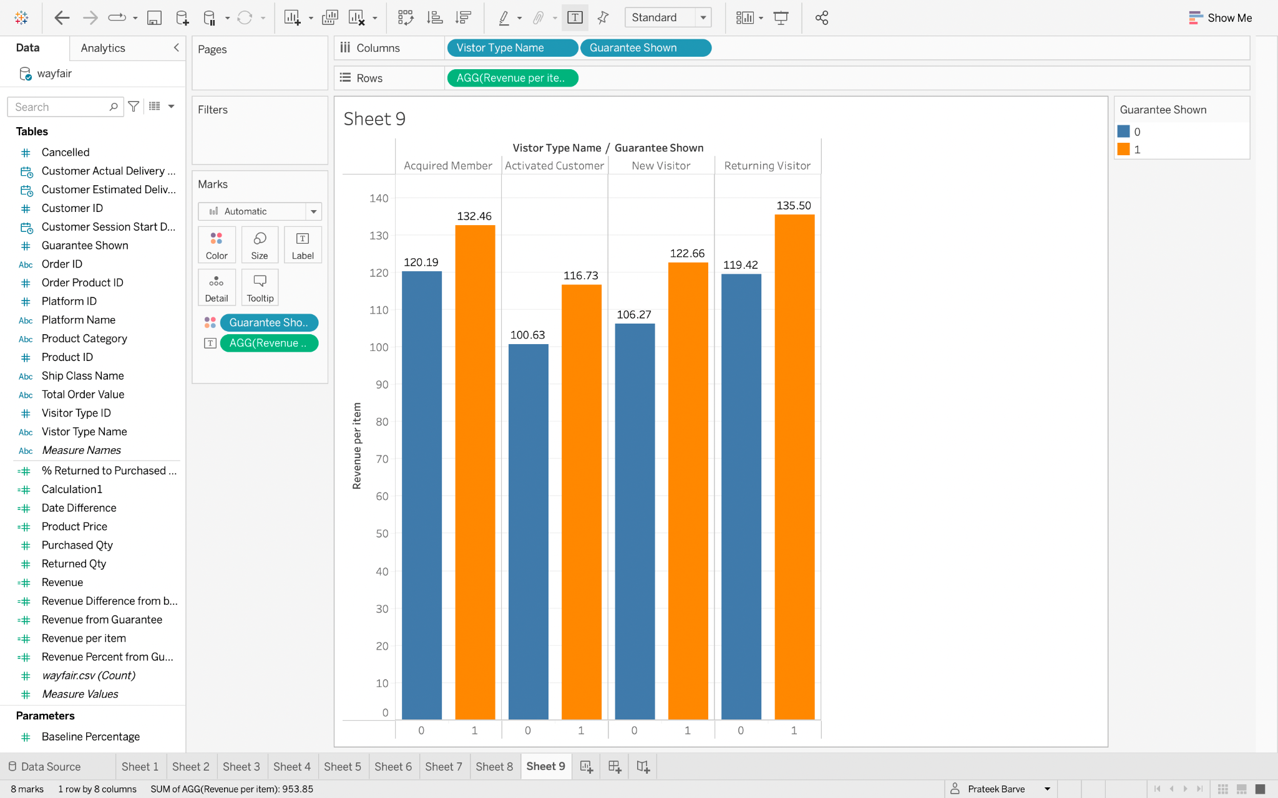

We further investigated the average revenue contribution per item purchased across all customer segments (visitor types) in Figure 3. In addition, we created a bar chart with visitor type name and guarantee shown in the column and the average revenue per item in the rows. The guarantee shown column is displayed in colors blue and orange for distinction and comparison between both groups. The analysis shows each visitor type in a separate pane with the corresponding revenue per item for group A and B within the pane. We can conclude from this visualization that for every category of visitor type, the average revenue per item purchased is higher for group B.

This is indicative of more optimal pricing and revenue maximization for group B’s purchases across all visitor types with that of returning visitors being the highest. It does appear that customers were motivated to purchase more optimally priced items after being shown the guarantee. We can conclude from these visualizations that group B contributes more proportionally to revenue than group A and hence the campaign is a success.